Blueberry Pancake Recipe Name___________________________________________________________
from John Handley HS

Find each limit in order to complete the recipe.

Ingredients:
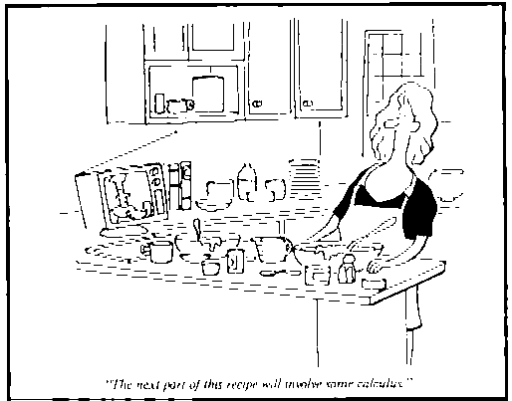
1. = _____ eggs
2. = _____ cups of all-purpose flour
3. = _____ cups of milk
4. = _____ cups of fresh, canned or frozen
blueberries (thawed and well- drained)
5. = _____ tablespoons of shortening or
vegetable oil
6. = _____ tablespoons sugar
"The next part of this recipe will involve some Calculus."
7. = _____ teaspoons of baking powder
8. = _____ teaspoon of salt

Beat egg with hand beater until fluffy. Beat in remaining ingredients just until smooth. Grease heated griddle. (To test griddle, sprinkle with a few drops of water. If bubbles skitter around, heat is just right.) Pour about 3 tablespoons of batter onto hot griddle. Cook until puffed and brown about the edges. Turn and cook until golden brown on both sides. Recipe makes four 9-inch pancakes.

